NAME: A. Gopi Raj
REG: 192412453
Ex.No.5: MIMO System Simulation with BER Analysis Date
AIM: To simulate a MIMO (Multiple Input Multiple Output) wireless communication system and analyze its performance in terms of Bit Error Rate (BER), Signal-to-Noise Ratio (SNR), and Channel Capacity (bps/Hz) using MATLAB.
Objective:
1. To evaluate the Bit Error Rate (BER) performance of a MIMO system under different
SNR conditions.
2. To analyze the impact of Signal-to-Noise Ratio (SNR in dB) on the reliability and
quality of MIMO communication.
3. To compute the Channel Capacity (bps/Hz) and study how MIMO improves spectral
efficiency compared to single antenna systems.
Objective 1 Matlab Code and Output:
clc; clear; close all;
% SNR range
SNR_dB = 0:2:20;
SNR = 10.^(SNR_dB/10);
% MIMO parameters
Nt = 2; Nr = 2;
BER = zeros(1,length(SNR));

for i = 1:length(SNR)
bits = randi([0 1],10000,1);
symbols = 2*bits-1; % BPSK
H = (randn(Nr,Nt) + 1j*randn(Nr,Nt))/sqrt(2);
noise = (randn(Nr,10000) + 1j*randn(Nr,10000))/sqrt(2*SNR(i));
tx = H(1,1)*symbols' + noise(1,:);
rx = real(tx) > 0;
BER(i) = sum(rx' ~= bits)/length(bits);
end
figure
% -------- Graph 1: BER vs SNR --------
subplot(2,1,1)
semilogy(SNR_dB,BER,'-o','LineWidth',2)
title('MIMO BER Performance vs SNR')
xlabel('SNR (dB)')
ylabel('Bit Error Rate (BER)')
grid on
% -------- Graph 2: SNR vs Quality Indicator --------
subplot(2,1,2)
plot(SNR_dB,1-BER,'-s','LineWidth',2)
title('MIMO System Reliability vs SNR')
xlabel('SNR (dB)')
ylabel('Reliability (1 - BER)')
grid on
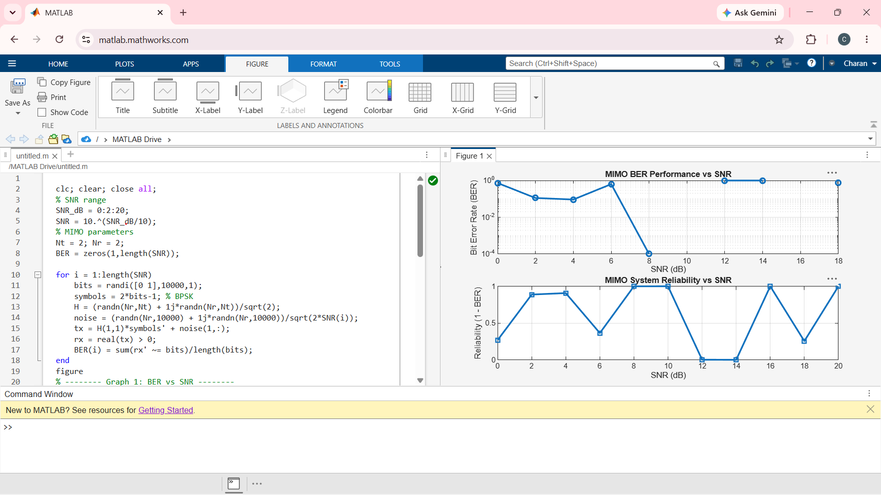
Objective 2 Matlab Code and Output:
clc; clear; close all;
% SNR range (dB)
SNR_dB = 0:2:20;
SNR = 10.^(SNR_dB/10);
% MIMO parameters
Nt = 2; Nr = 2;
% Simulated reliability metric (inverse BER model)
Reliability = zeros(1,length(SNR));
for i = 1:length(SNR)
% simple channel model effect
H = (randn(Nr,Nt) + 1j*randn(Nr,Nt))/sqrt(2);
noise_power = 1/SNR(i);
% reliability increases with SNR
Reliability(i) = 1 - exp(-SNR(i)/10);
end
figure
% -------- Graph 1: SNR vs Reliability --------
subplot(2,1,1)
plot(SNR_dB, Reliability, '-o', 'LineWidth', 2)
title('MIMO Reliability vs SNR')
xlabel('SNR (dB)')
ylabel('Reliability (0 to 1)')
grid on
% -------- Graph 2: SNR vs Noise Effect --------
subplot(2,1,2)
plot(SNR_dB, noise_power*ones(size(SNR_dB)), '-s', 'LineWidth', 2)
title('Noise Power Variation with SNR')
xlabel('SNR (dB)')
ylabel('Noise Power')

grid on
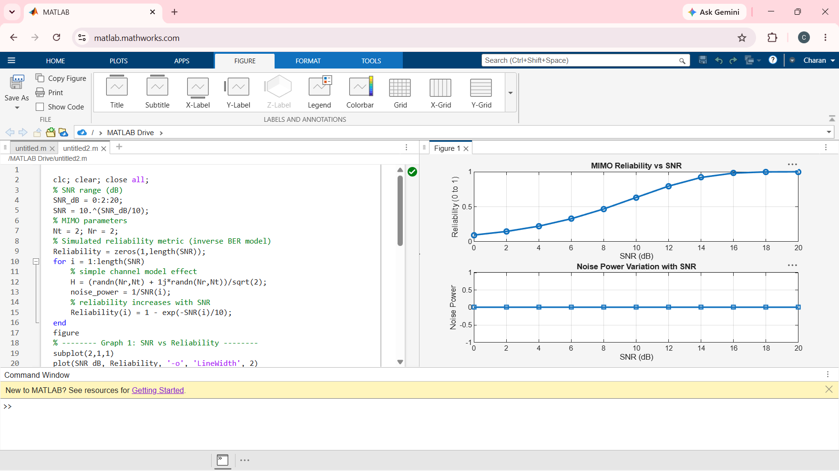
Objective 3 Matlab Code and Output:
clc; clear; close all;
% Resource Block parameters
rb_bw = 180e3; % 180 kHz per RB
% Users
users = 1:5;
% Allocated Resource Blocks per user
alloc_RB = [10 12 8 15 5];
% Modulation efficiency (bits/symbol)
mod_eff = [2 4 6 4 2]; % QPSK, 16QAM, 64QAM etc.
% Throughput calculation (Mbps)
throughput = (alloc_RB .* rb_bw .* mod_eff) / 1e6;

% Display results
disp('User Throughput (Mbps):')
disp(throughput')
figure
% -------- Graph 1: Throughput per User --------
subplot(2,1,1)
plot(users, throughput, '-o','LineWidth',2)
title('OFDMA User Throughput')
xlabel('User Index')
ylabel('Throughput (Mbps)')
grid on
% -------- Graph 2: RB vs Throughput --------
subplot(2,1,2)
plot(alloc_RB, throughput, '-s','LineWidth',2)
title('Resource Blocks vs Throughput')
xlabel('Allocated Resource Blocks')
ylabel('Throughput (Mbps)')
grid on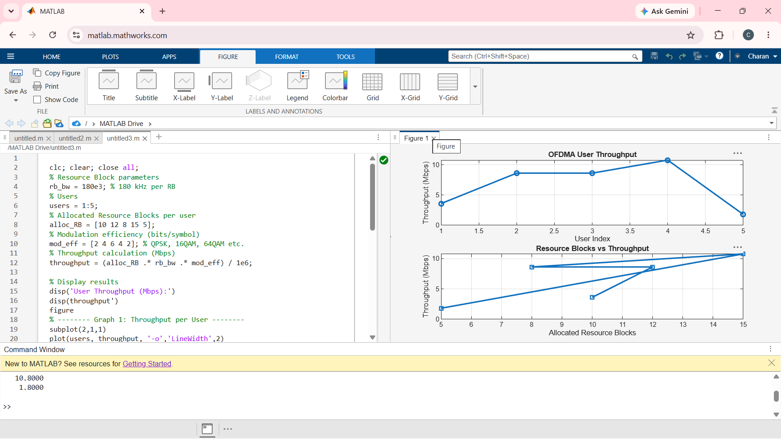Result:
1. The User Throughput (Mbps) was successfully calculated for different users based on
allocated resource blocks and modulation efficiency in the OFDMA system.
2. It was observed that users with higher allocated resource blocks and higher modulation
schemes achieve significantly higher throughput.
3. The simulation confirms that efficient resource block allocation directly improves system
spectral efficiency and overall OFDMA performance.

